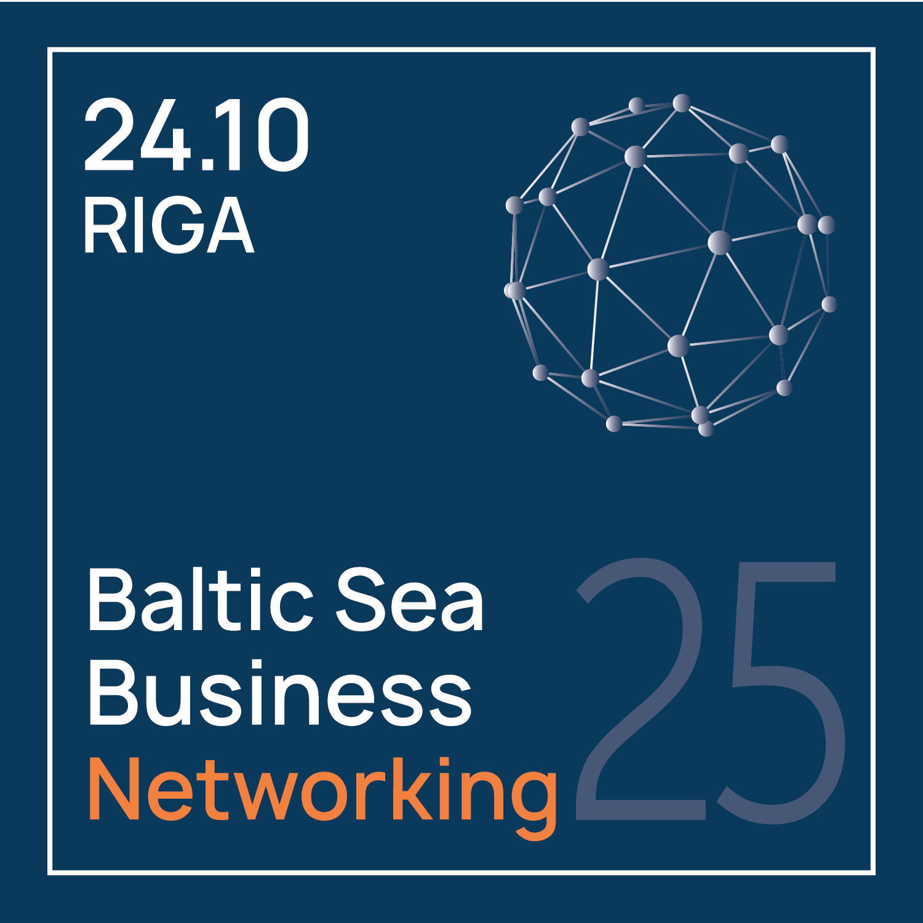 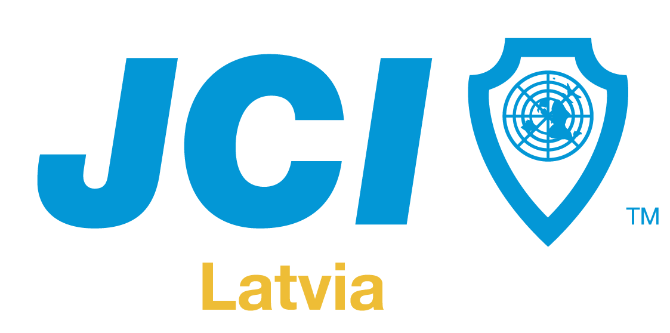

**INFORMATION FOR THE MEDIA**

**August 22, 2025**

**The Longest Coffee Break in Baltic Business – October 24 in Riga** *Where conversations turn into deals*

Is it possible to find new business partners, enter a new market, and close deals in just one day?  
 The answer is – yes. And it will happen in Riga at the **Baltic Sea Business Networking Congress 2025**, where the longest “coffee break” in the history of Baltic business will transform into a powerful international networking and deal-making platform.

The forum in Riga will bring together more than 250 entrepreneurs from across the Baltic Sea region to expand their business and find new partners – all during the longest “coffee break” ever experienced.

Anyone who has attended conferences knows – most valuable contacts and deals are made not during presentations, but in between them, in conversations over coffee or between sessions. This event takes that truth to a new level – it will be one big, purposefully organized “coffee break” lasting the entire day. Every contact and meeting will be carefully matched to each participant’s specific business goals.

This is not just another inspirational conference – it is a practical, collaboration- and results-oriented B2B cross-industry, cross-border, and strategic forum for entrepreneurs who seek real deals, export breakthroughs, and a network of strategic partners in the Baltic Sea region.

**About the Event**

JCI Latvia invites entrepreneurs, company leaders, and decision-makers to the region’s most ambitious B2B networking event – **Business Without Borders: Baltic Sea Business Networking Congress 2025**, which will take place on October 24 at the Radisson Blu Daugava Hotel in Riga.

The forum will gather participants from Latvia, Lithuania, Estonia, Finland, Sweden, and other Baltic Sea region countries to build new partnerships, expand exports, and conclude real business deals across different industries and national borders. The event will offer not only inspiration but also practical opportunities for business growth and international cooperation.

Its goal is to strengthen cross-border partnerships, increase export potential, and enhance the economic resilience of the Baltic region while responding to global economic, political, and security challenges. JCI Latvia aims to create an environment where entrepreneurs can meet, exchange experiences, and make deals – overcoming both geographical and mindset barriers. The forum will serve as a unique cooperation platform that will strengthen Latvia’s sustainability, promote international security, and restore Riga’s position as a business hub of the Baltics.

The event will also feature a masterclass by **Niko Visuri** – one of the top Nordic business trainers, who will reveal the secrets of body language and sales that have helped more than 10,000 professionals achieve success.

**Niko Visuri** is an experienced lecturer, trainer, and event speaker who has delivered training and presentations for hundreds of companies, universities, seminars, and congresses both in Finland and abroad. For his achievements as an international adult education trainer, he has been awarded the prestigious Junior Chamber International honor – the title of **International Training Fellow**.

**A Strategic Networking Format**

Instead of a traditional conference, a purposefully designed model will be implemented to help entrepreneurs find business partners, establish strategically meaningful contacts, expand into new markets, and turn conversations into deals.

The event is intended for result-oriented entrepreneurs who are seeking the right partners, new market opportunities, and export breakthroughs.

**Baltic Sea Business Networking Congress 2025 offers a unique set of benefits:**

**AI-powered B2B networking platform**, specially developed for this event and available exclusively to registered participants. It will analyze participant profiles and goals, enabling them to connect with the most relevant partners even before the event – saving time and making meetings as valuable as possible.

**Key features:**

* AI-driven partner matching based on profile compatibility and goals
* Real-time compatibility checks and automated meeting scheduling
* Access to *Power Teams* working groups (Baltics, DACH, Persian Gulf, Netherlands & Flanders, Scandinavia, United Kingdom, USA, and more)
* Exclusive access for participants only

**Additional advantages:**

* International keynote speakers
* Practical masterclasses and entrepreneurial success stories
* Cross-industry and international B2B networking
* Special networking zone and the opportunity to showcase personalized exhibition stands

**Organizers**

The event is organized by [**Junior Chamber International Latvia (JCI Latvia)**](https://jci.lv/) – part of a global network of leaders and entrepreneurs in more than 100 countries, creating platforms for growth, collaboration, and positive impact on society. JCI Latvia is hosting this event to position Latvia as the Baltic hub for business diplomacy, innovation, and international cooperation by leveraging its extensive global network.

The networking impact will be further enhanced by [**BNI Latvia**](https://bni.lv/lv/index), the global leader in business networking, whose international communication channels will connect participants with an even wider network of entrepreneurs worldwide. Unlike traditional platforms, JCI brings together current and future leaders through informal diplomacy and global collaboration, ensuring strategic results in a shorter time while strengthening Latvia’s international visibility.

**Media Information**

During the event, media representatives will have access to a dedicated press room with workstations, Wi-Fi, and opportunities to conduct interviews with speakers and participants.

**Accredited** journalists, photographers, and other media representatives will receive:

* Access to all event areas (including the B2B networking space and conference hall)
* The opportunity to arrange interviews with participants and keynote speakers
* Official photo and video materials after the event
* Press releases and other informational resources

**More information and accreditation:**<https://balticnetworking.com/mediakit/>

The number of participants is limited – **up to 500.** **Early bird tickets are available until August 31.**

**Registration and information:**<https://balticnetworking.com/>

**Contacts:** Igors Djačenko  
 JCI Senator  
 igors@digimedia.lv  
 +371 22331444

Marta Rautenšilde President, JCI Latvia  
 marta.rautenschild@gmail.com  
 +371 29400930